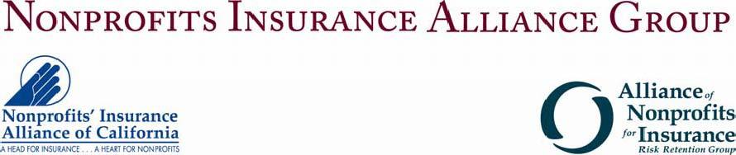
SPECIAL EVENT ENDORSEMENT REQUEST
Please complete this form for any special events or fundraisers that need to be added to the policy mid-term. Please note: we have added a new endorsement for fundraisers at no additional charge, the ANI/NIAC E-70 09 13. This blanket fundraising endorsement grants general liability coverage to all fundraisers unless they are excluded on the endorsement. We define a “Fundraiser” as any event sponsored or co-sponsored by you with the primary purpose of raising monetary contributions.
Member Insured Name: CHADD__________ Customer # 43374_________________
Is the named insured sponsoring/hosting the event?
If no what is the insured’s participation in the event?
Name of Event:
Type of Event:
Date of Event: # of Attendees:
Location of Event:
Activities Involved:
Anticipated Revenue (gross):
Will food, beverages or alcohol be served?
Safety precautions if alcohol is served:
Other Information:
Producer name: _GORGES & CO., INC._________________ Date:

